Preparation of a formatted Abstract for Helmut-Schaefer-Price
[Title of Master Thesis]

Authors Name/s per 1st Affiliation¹, Authors Name/s per 2nd Affiliation²
¹Dept. name of organization, City, Country, e-mail address
²Dept. name of organization, City, Country, e-mail address

Keywords: Keyword 1, Keyword 2, Keyword 3

Motivation and Background
That is why I am writing about this topic [1], [2].

Methodological Procedure
Description of the methodology. Example of a figure: Figure 2-1.

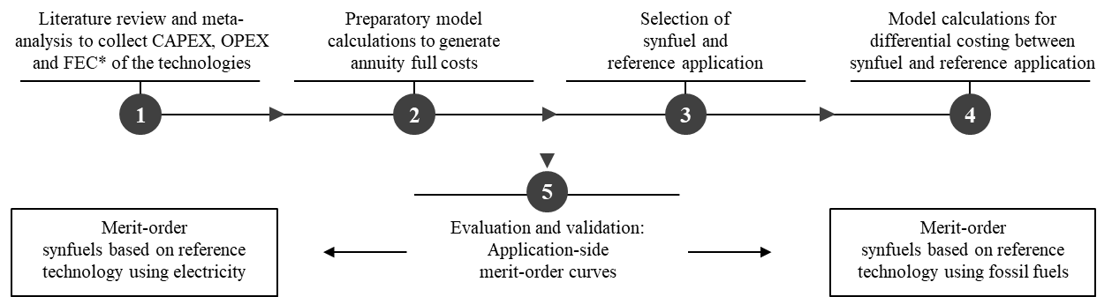
Figure 2-1: Overview of the five main components of the methodological procedure

Results and Discussion
The results of the master's thesis show the following scientific findings

Conclusion
Conclusion and outlook according to the master thesis.

Literature
[1] | Hübner, Tobias et al.: 2019 Small-scale modeling of individual GHG abatement measures in the industry. In: 8th International Ruhr Energy Conference (INREC) (University Duisburg-Essen) 09/2019. München: Forschungsgesellschaft für Energiewirtschaft (FfE), 2019.
[2] | Hübner, Tobias et al.: Application-side merit-order-curves for synthetic fuels in the German energy system. In: 13th International Conference on Energy Economics and Technology Mai/2019. Dresden: TU Dresden, 2019.

Appendix
In the Appendix, the basic data are available.

Appendix A: Specific CAPEX and OPEX
Example of a table: Table 6-1
Table 6-1: Specific CAPEX and OPEX of selected technologies using conventional fossil fuels in the household sector
Household sector |  |  | Specific CAPEX  [€/bldg] |  | Specific OPEX  [€/bldg]
building type | building age | fossil fuel/application | 2020 | 2050 | 2020 | 2050
detached house | $≤$ 1994 | oil boiler | 831 | 758 | 1 085 | 1 396
 |  | gas boiler | 1 554 | 1 499 | 533 | 660
 | $≥$ 1995 | oil boiler | 690 | 784 | 706 | 877
 |  | gas boiler | 1 433 | 1 756 | 349 | 423

Specifications for the abstract
- The abstract can be written in German or English
- The content of the abstract may contain a maximum of one page or a maximum of 500 words
- Additionally figures and tables can be placed in the appendix
- The abstract must include a complete curriculum vitae in the appendix
- The abstract must include a complete excerpt from the university certificate

